製作一個簡易的MVC Web應用程式
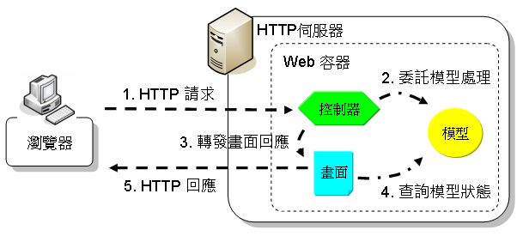
1. Model : HelloModel.java，根據使用者的請求參數不同，會取得不同的Message參考

import java.util.*;
public class HelloModel {
private Map<String, String> messages;
public HelloModel() {
messages = new HashMap<String, String>();
messages.put("John", "Hello");
messages.put("Ray", "Welcome");
messages.put("Vincent", "Hi");
}
public String sayHello(String user) {
String message = messages.get(user);
return message + ", " + user + "!";
}
}
2.將HelloModel.java 儲存於C:\apache-tomcat-9.0.24\webapps\ROOT\WEB-INF\classes並編譯
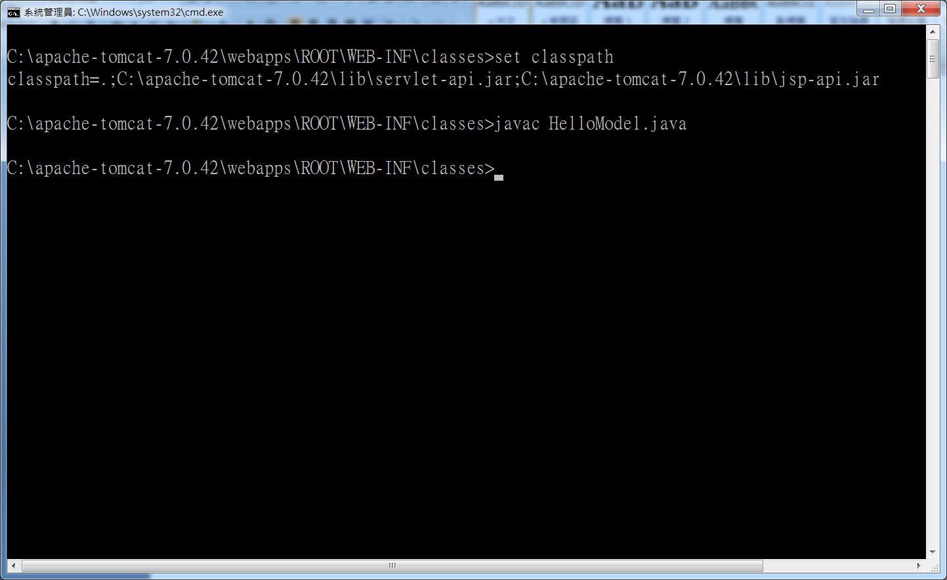
3. Controller :建立HelloController.java程式儲存於C:\apache-tomcat-9.0.24\webapps\ROOT\WEB-INF\classes並編譯

import java.io.IOException;
import javax.servlet.ServletException;
import javax.servlet.annotation.WebServlet;
import javax.servlet.http.HttpServlet;
import javax.servlet.http.HttpServletRequest;
import javax.servlet.http.HttpServletResponse;

@WebServlet(name="HelloController", urlPatterns={"/hello.do"})
public class HelloController extends HttpServlet {
private HelloModel hello = new HelloModel();

@Override
protected void doGet(HttpServletRequest req, HttpServletResponse resp)
throws ServletException, IOException {
String name = req.getParameter("user");
String message = hello.sayHello(name);
req.setAttribute("message", message);
req.getRequestDispatcher("helloView.jsp").forward(req, resp);
}
}
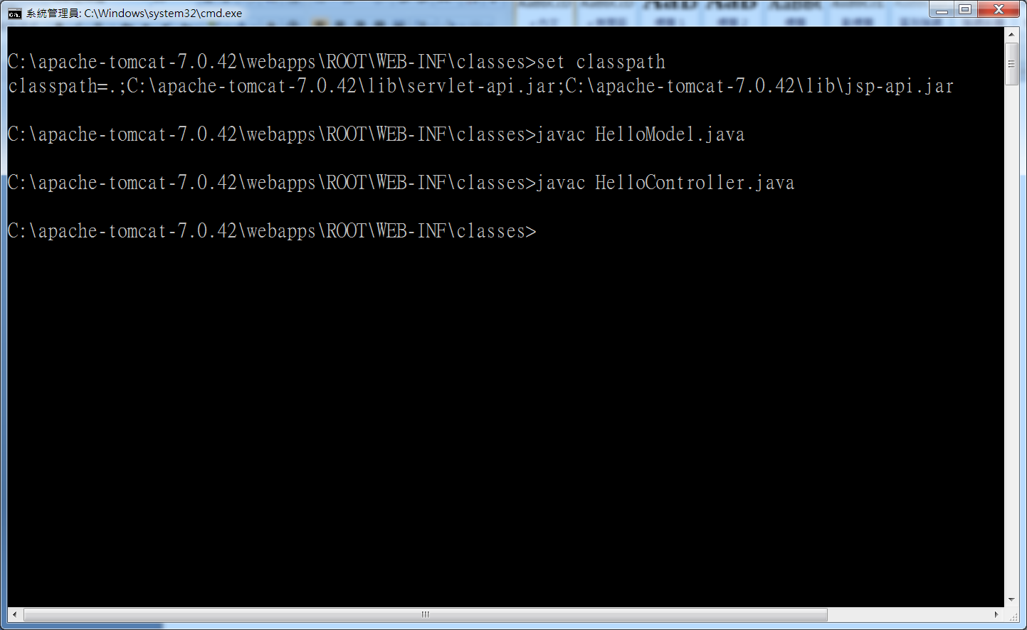
4. View :建立helloView.jsp程式儲存於C:\apache-tomcat-9.0.24\webapps\ROOT
<%@page contentType="text/html" pageEncoding="UTF-8"%>
<html>
<head>
<meta http-equiv="Content-Type"
content="text/html; charset=UTF-8">
<title>${param.user}</title>
</head>
<body>
<h1>${message}</h1>
</body>
</html>

5. 編輯C:\apache-tomcat-9.0.24\webapps\ROOT\WEB-INF \web.xml
<servlet>
<servlet-name>HiController</servlet-name>
<servlet-class>HelloController</servlet-class>
</servlet>
<servlet-mapping>
<servlet-name>HiController</servlet-name>
<url-pattern>/hello.do</url-pattern>
</servlet-mapping>
